Cisco XDR automation build guide
Oct 12, 2026 · @Dev Bhargav

Overview
A high-priority incident now follows two paths: an automation rule runs the Webex and ServiceNow workflows immediately, and an assignment rule attaches the analyst playbook. This guide walks from the first rule to the current state, with what each integration needs.
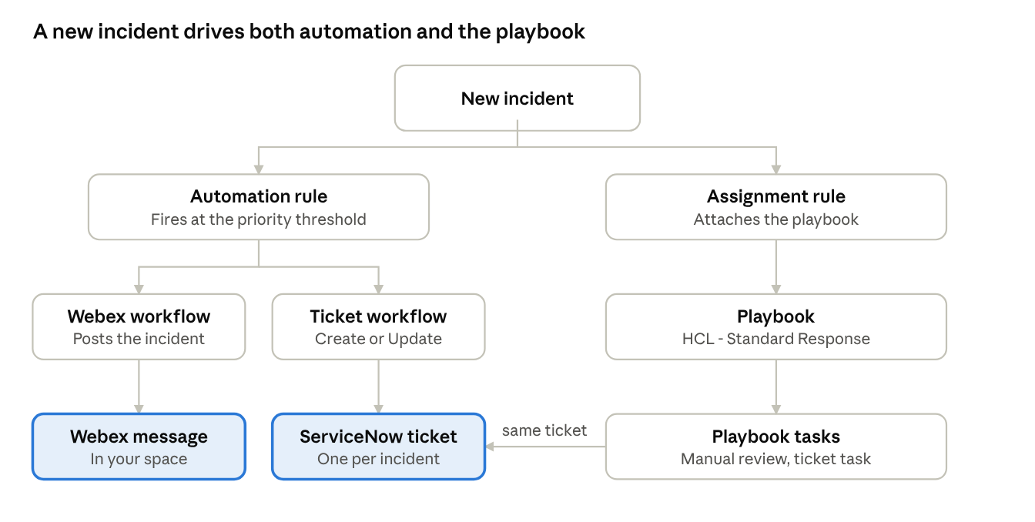
incident flow, rule and playbook paths
Highlighted boxes are the results you see: a Webex message and a ServiceNow ticket. The playbook's ticket task updates the same ticket instead of creating a second one.

Before you start: integrations and what each needs
Every workflow talks to an outside system through a target (where to connect) and an account key (the credentials). Set these up first, or the workflow will not validate.
Integration | What you need | Where to set it up | Common trap
Cisco XDR (built in) | Nothing extra. Platform APIs, Private Intelligence API and Conure APIs show as enabled | Automate > Targets (already present) | None
Webex | A Webex bot (created at developer.webex.com) with its access token, and the bot added to your Webex space | Administration > Integrations > Webex, then a Webex target with the account key | The room name must match the space exactly. The bot must be a member of the space
ServiceNow | Instance dev453866.service-now.com, a dedicated user xdr_integration with the itil role, and its password | Administration > Integrations > ServiceNow, then the target | Untick Password needs reset, tick Internal Integration User, and wake the developer instance first
Jira Cloud (alternative) | Site URL, account email, an API token, a project key and an issue type name | Jira target and account key | Project key has no -1 suffix, and the issue type must exist, such as Task
Email (SMTP) | An SMTP host, port, and a login that allows SMTP AUTH | Automate > Targets > SMTP | Outlook and Microsoft 365 often block SMTP AUTH. SendGrid needs single sender verification. Unresolved so far, so Webex is the working notification path
Other things to have ready:
- An XDR account with permission to create workflows, rules and playbooks.
- The XDR region base URL for API work: visibility.apjc.amp.cisco.com/iroh/ and automate.apjc.security.cisco.com/api/.
- A test incident. Incident INC-18 has been used for message previews.

Step 1: a first workflow and the incident rule
Start small so you can prove the trigger works before adding real actions.

1a. Build the test workflow
- Go to Automate > Workflows > New Workflow and choose Incident Response, so the workflow receives the incident as its input.
- Name it Rule-Test. Add a Set Variables step that writes a short message, for example the incident title.
- Declare any variable the workflow uses. A variable of type Input is passed in, Output is returned, and Static is a fixed value. An undeclared variable is why the earlier validation showed Set Variables as invalid.
- Validate, then Install. If validation shows warnings, fix them rather than skipping them.
- Run it once manually and open the run to confirm each step passed.

1b. Create the automation rule
- Go to Automate > Automation Rules > New Rule.
- Set the trigger to incident created (or the incident status change you want).
- Add a condition. To act only on serious incidents, use priority score at or above your threshold, for example 800. The score runs from 0 to 1000.
- Under Workflows, add Rule-Test.
- Choose the rule type. A standalone rule runs independently. A priority rule is evaluated in order, and Stop processing subsequent rules can end the list early. Prefer standalone unless you need that ordering.
- Save and enable the rule.

1c. Prove it fires
Create or wait for an incident. Open the workflow's Runs page and confirm a run appears for that incident. If the rule fired, the same incident ID will be shown against the run.
Tidy-up to do: keep the rule title, condition and description consistent with each other. An earlier rule still described "Runs Rule-Test" while its condition had changed.

Step 2: Webex notification

2a. Connect Webex
- At developer.webex.com, create a bot and copy its access token. Add the bot to your Webex space, because it can only post where it is a member.
- In XDR go to Administration > Integrations, enable Webex, and save the token as the account key.
- In Automate > Targets, check a Webex target exists. If you see "no valid account key", the Webex integration is not connected yet.

2b. Install the workflow
- Open Exchange, find Webex - Send Message for New Incidents, and install it.
- When asked, fill the variables: Sources (the incident sources to include) and Webex Room Name (the exact name of your space).
- On the target warning, pick your Webex target. This fixes "Execute on this target group" errors.
- Validate and install.

2c. Attach it to the rule
- Open the automation rule from Step 1 and add the Webex workflow under Workflows.
- Save. Webex now posts when the rule fires.

2d. Customise the message
In the Webex activity, put your text in the Markdown Message field and leave Plain Text Message empty. Delete each <<PLACEHOLDER>> and insert the real value from the variable picker (x), or type $ as a shortcut. The workflow then fills in each new incident's own values instead of fixed text.
Placeholder | Insert from the picker
Incident ID | Incident ID or number
Title | Incident title
Priority score | Priority score
Assessment | Assessment
Sources | Sources list
Status | Incident status
Created, Last updated | Created time, updated time
Link | Incident link
Templates are in webex_incident_message.md and .txt. Never type INC-18's values in by hand, or every alert will show INC-18.
Still open: the message in your workflow still contained <<PLACEHOLDER>> text, so these variables need inserting.

Step 3: ServiceNow ticketing

3a. Prepare ServiceNow
- Wake your developer instance at https://dev453866.service-now.com. Developer instances hibernate when idle.
- In User Administration > Users, create xdr_integration. Set a password with Set Password, untick Password needs reset, tick Internal Integration User (or Web service access only), and set Active.
- On the Roles tab add itil.
- Test from your laptop: curl -u xdr_integration:PASSWORD "https://dev453866.service-now.com/api/now/table/incident?sysparm_limit=1". JSON back means it works. 401 is credentials, 403 is a missing role.

3b. Connect ServiceNow in XDR
On the workflow install page, the ServiceNow row shows "Integration missing" until you enable it. Click here beside "Enable it" (or go to Administration > Integrations), enter the host dev453866.service-now.com, the xdr_integration username and the password. Return to the install page and refresh. Your target should now appear.

3c. Install the right workflow
Two Cisco-managed workflows are offered:
Workflow | Behavior | Use when
ServiceNow - Create or Update Ticket for Incident (v1.0) | Creates a ticket, or updates the same one on later runs | Recommended. Safe on rules and playbooks, avoids duplicates
ServiceNow - Create Ticket for Incident (v1.1) | Creates a ticket only | A one-time create from a playbook task
Both set the XDR incident status to Incident Reported. Install the first one and fill its variables:
Variable | Value
Caller User ID | xdr_integration, a real ServiceNow username
Assignee | Blank, or admin for testing
Assignment Group | Blank. A wrong group name can reject the ticket

3d. Test
Run the workflow on a test incident, then open Incident > All in ServiceNow and look for the new ticket. Run it again on the same incident. The existing ticket should update, not a second one appear.

Alternative: Jira Cloud
The Jira workflow failed at first because of two wrong values: the Project Key was entered as KTHHZXKY-1 and the Issue Type Name as "Security Incidents". Use the key without -1, an issue type that exists such as Task, and clear Project ID, Issue Type ID and Watchers. Read the child "Jira Cloud - Create Issue" step for the real error. Whether this is now fixed is unconfirmed.

Step 4: the playbook and its assignment rule
A workflow is one automated job. A playbook is the analyst's checklist for handling an incident, split into phases, and it can run workflows as tasks.

4a. Build the playbook
- Go to Automate > Playbooks > New Playbook and name it HCL - Standard Response.
- The phases are fixed: Identification, Containment, Eradication, Recovery. You add tasks inside each phase. There is no phase picker on the task itself.
- Add a task, for example Review incident summary and affected assets. A task can be manual (an analyst does it) or automated (it runs a workflow).
- Cisco-managed tasks can be used in a custom playbook, so you can mix them with your own.
- Save, then Publish. Publishing locks that version. To change it later, create a new version.

4b. Add the ServiceNow and Webex tasks
A task runs one workflow, so add two tasks rather than one combined task:
Phase | Task | Type | Workflow
Identification | Review incident summary and affected assets | Manual | None
Identification | Create or update ServiceNow ticket | Automated | ServiceNow - Create or Update Ticket for Incident
Identification | Notify the team on Webex | Automated | Webex workflow, only if the rule does not already send it
Keep the manual review task. It is real analyst work and the automated tasks should sit beside it, not replace it.

4c. Create the assignment rule
An assignment rule decides which playbook is attached to a new incident. Create one that attaches HCL - Standard Response to the incidents you care about, for example by priority. Assignment rules apply only when an incident is created, so existing incidents do not receive the playbook. Test with a new incident.

Step 5: wire it together
The pieces have different jobs, so decide who does what before you connect them.
Piece | Job | Triggered by
Automation rule | Reacts instantly to an incident event | The incident being created or changing
Workflow | Does one automated job, such as a ticket or a message | The rule, or a playbook task
Assignment rule | Attaches a playbook to a new incident | Incident creation
Playbook | Gives the analyst a checklist and can run workflows | Attached by the assignment rule
Recommended setup:
- One standalone automation rule for incidents at or above your priority threshold. It runs the Webex workflow and the ServiceNow Create or Update workflow, in that order of importance: ticket first, then notification.
- One assignment rule that attaches HCL - Standard Response to the same incidents.
- Playbook tasks for analyst work, plus an optional manual ServiceNow task so an analyst can push an updated status later.
- Keep Webex in either the rule or the playbook, not both. Otherwise the room gets two messages for one incident.
Why the Create or Update workflow matters: if the rule and a playbook task both run it, the second run updates the existing ticket instead of creating a duplicate. The create-only workflow does not give you that protection.
Rule type: your rule was changed from standalone to priority. Priority rules are evaluated in order and can stop later rules, so go back to standalone unless you need that ordering.
To make the rule fire automatically on high-priority incidents, set the condition on the incident priority score (for example 800 or above) with the incident created trigger, rather than changing the status by hand.

Testing and troubleshooting
Test in this order: run the workflow by hand, then fire the rule, then create a new incident for the playbook. When a run fails, open its Runs entry and read the child step that failed. The parent only shows that something went wrong.
Symptom | Cause | Fix
Install shows "Target validation error" for email | SMTP login rejected | Use a verified single sender, a Gmail app password, or ask IT to allow SMTP AUTH
"No valid account key" on a Webex target | Webex integration not connected | Enable Webex in Administration > Integrations first
Webex "Execute on this target group" warning | No target selected on the workflow | Choose the Webex target in the workflow
Workflow validation: Set Variables invalid | Variable not declared | Declare it as Input, Output or Static
Install "succeeded with warnings" | Validation was skipped | Resolve the warnings before relying on the workflow
Jira run fails | Wrong Project Key or Issue Type Name | Key without -1, a real issue type, and clear the ID and Watchers fields
ServiceNow 401 | Bad username or password, or password reset required | Reset the password and untick Password needs reset
ServiceNow 403 | Missing role | Add itil to xdr_integration
ServiceNow 404 or timeout | Wrong host, or sleeping instance | Check dev453866.service-now.com and wake the instance
Workflow "succeeds" but did nothing | Continue workflow execution on failure is on | Turn it off while testing
Playbook not on an incident | Assignment rules apply only at creation | Test with a new incident
Webex shows <<PLACEHOLDER>> text | Variables not inserted | Replace each with the picker value
Two Webex messages per incident | Webex in both the rule and the playbook | Keep it in one place

Current status
Done and proven:
- ☒ Hello-XDR and Rule-Test workflows built and run
- ☒ Automation rule fires on incidents
- ☒ Playbook HCL - Standard Response published
- ☒ Assignment rule created
- ☒ Webex workflow installed, validated and firing from the rule
- ☒ ServiceNow developer instance and xdr_integration user created
Left to do:
- ☐ Enable the ServiceNow integration in XDR and pick the target
- ☐ Install ServiceNow - Create or Update Ticket for Incident and run it on a test incident
- ☐ Confirm a second run updates the ticket and does not duplicate it
- ☐ Add the ServiceNow and Webex tasks to the playbook and publish a new version
- ☐ Replace <<PLACEHOLDER>> text in the Webex message with picker variables
- ☐ Choose Webex in the rule or the playbook, not both
- ☐ Return the rule to standalone and align its title, condition and description
- ☐ Confirm the Jira failure is fixed, or retire Jira in favour of ServiceNow
- ☐ Fix email delivery, or drop it in favour of Webex
- ☐ Plan containment with Cisco Secure Endpoint managed workflows
- ☐ Clarify which endpoint product is meant by "ERD-M"
- ☐ Capture screenshots and run evidence for the deliverables sheet

